**Machine Learning - Task 4**

**Moshe Binieli – 311800668**

Message for Exercise Tester:

After I trained the models and created the first report file which contains the epochs and loss graph, I noticed I forgot about the accuracy graphs.

Therefore, I run the accuracy graphs again and tried to make it as close as possible to the epochs data, so you might see a **little** difference between the epochs data and the accuracy graphs.

**To summarize** the epochs image and the test image and the loss graph are fine, only the accuracy graph might be a little different, thank for understanding.

**The chosen model that performs the best is: Model C.**

**Model A**

At this model, the hyperparameters are defined like this, **Epochs**: 10, **Learning rate**: 0.001.

This model contains 2 hidden layers, the first hidden layer is size 100 and the second hidden layer is in size 50, they are using RELU activation function, this model uses the ADAM optimizer.

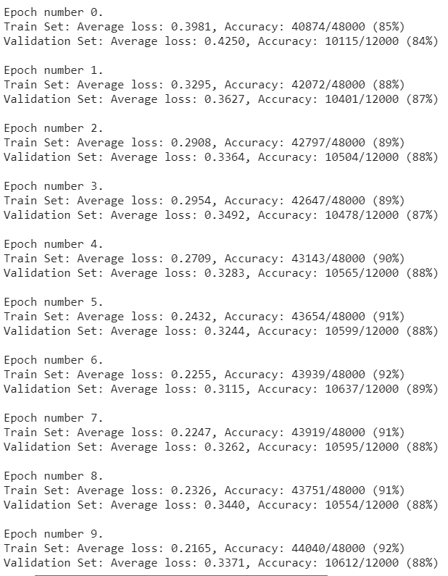



* Train set loss: 0.2165

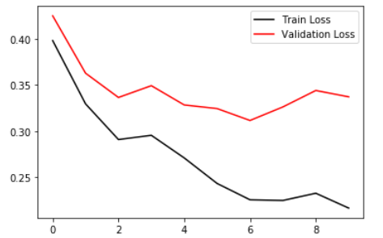* Validation set loss: 0.3371

* Test set loss: 0.3703

* Train set accuracy: 92%

* Validation set accuracy: 88%

* Test set accuracy: 87%

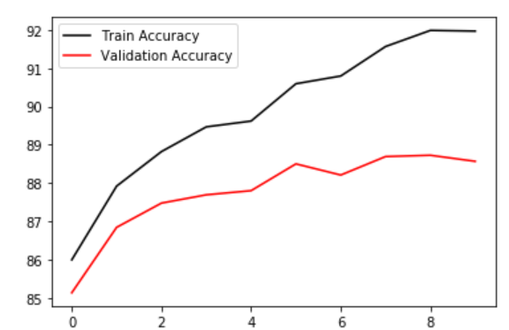

**Model B**

At this model, the hyperparameters are defined like this, **Epochs**: 10, **Learning rate**: 0.001.

This model contains 2 hidden layers, the first hidden layer is size 100 and the second hidden layer is in size 50, they are using RELU activation function, and before each activation function there is dropout layer, this model uses the ADAM optimizer.

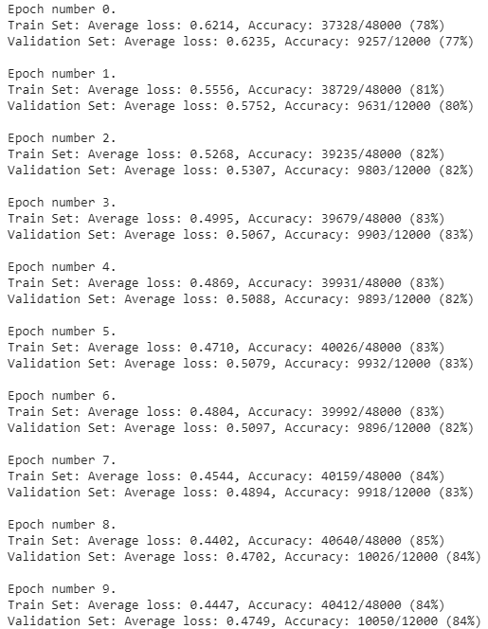



* Train set loss: 0.4447

* Validation set loss: 0.4749

* Test set loss: 0.5183

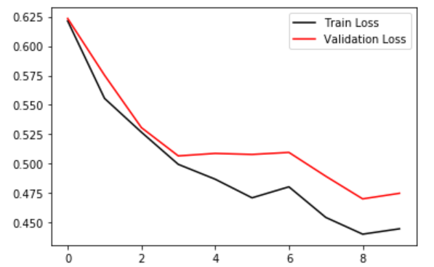* Train set accuracy: 84%

* Validation set accuracy: 84%

* Test set accuracy: 82%

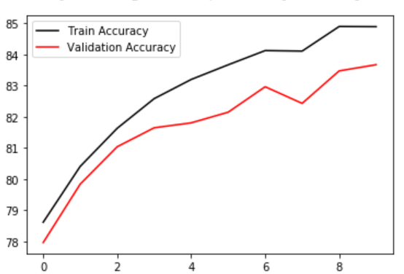

**Model C**

At this model, the hyperparameters are defined like this, **Epochs**: 10, **Learning rate**: 0.001.

This model contains 2 hidden layers, the first hidden layer is size 100 and the second hidden layer is in size 50, they are using RELU activation function, before each activation function there is batch normalization layer, this model uses the ADAM optimizer.

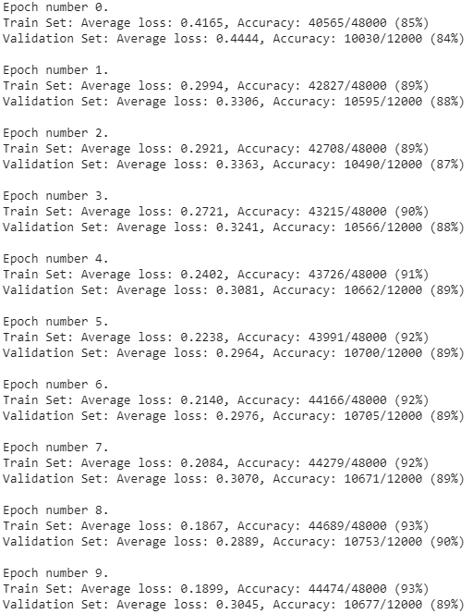



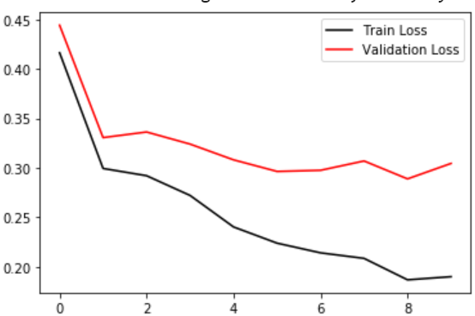* Train set loss: 0.1899

* Validation set loss: 0.3045

* Test set loss: 0.3401

* Train set accuracy: 93%

* Validation set accuracy: 89%

* Test set accuracy: 87%

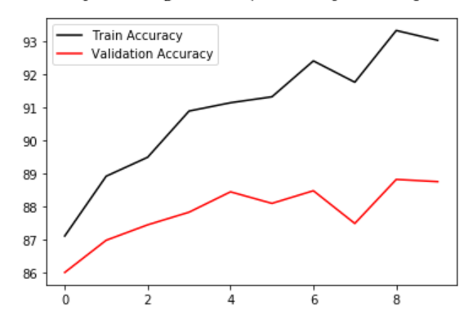

**Model D**

At this model, the hyperparameters are defined like this, **Epochs**: 10, **Learning rate**: 0.001.

This model contains 5 hidden layers, the first hidden layer is size 128, the second hidden layer is in size 64, the third hidden layer is in size 10, the forth hidden layer is in size 10 and the fifth hidden layer is in size 10 they are using RELU activation function, this model uses the ADAM optimizer.

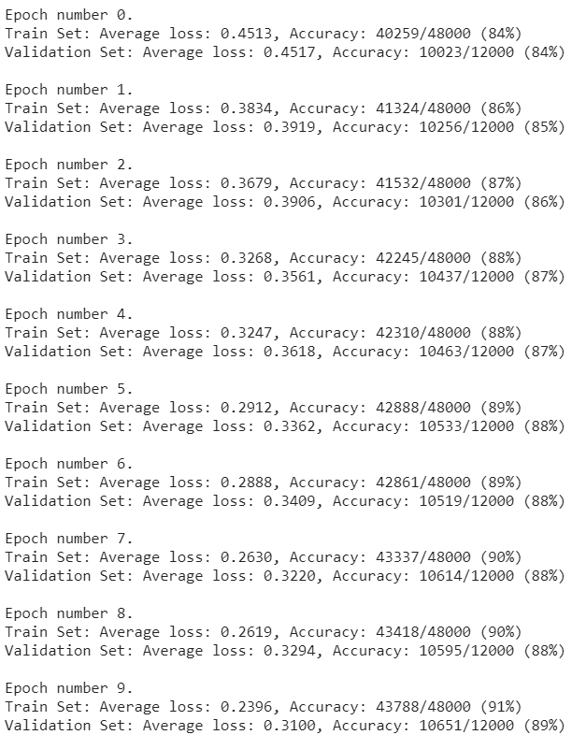



* Train set loss: 0.2396

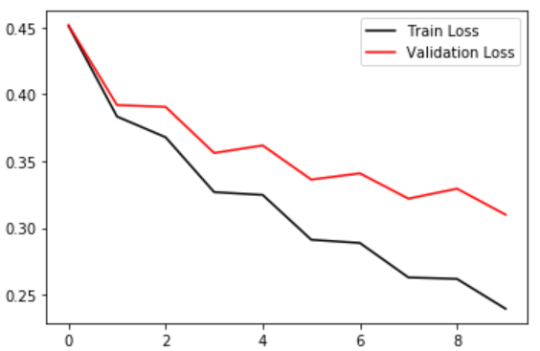* Validation set loss: 0.3100

* Test set loss: 0.3493

* Train set accuracy: 91%

* Validation set accuracy: 89%

* Test set accuracy: 87%

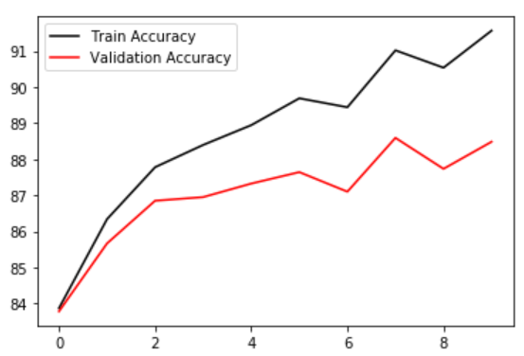

**Model E**

At this model, the hyperparameters are defined like this, **Epochs**: 10, **Learning rate**: 0.001.

This model contains 5 hidden layers, the first hidden layer is size 128, the second hidden layer is in size 64, the third hidden layer is in size 10, the forth hidden layer is in size 10 and the fifth hidden layer is in size 10 they are using SIGMOID activation function, this model uses the ADAM optimizer.

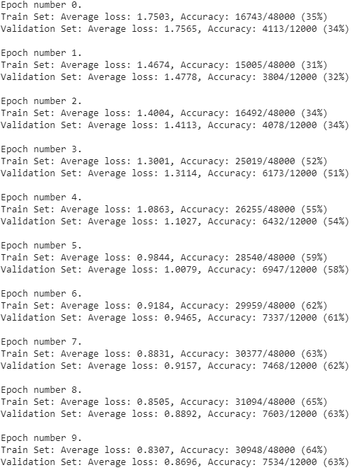



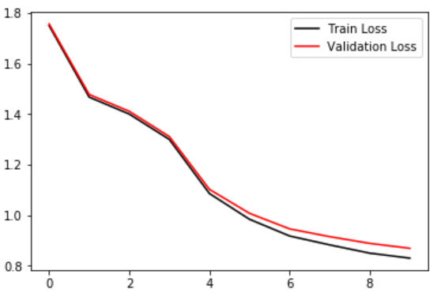* Train set loss: 0.8307

* Validation set loss: 0.8696

* Test set loss: 0.8804

* Train set accuracy: 64%

* Validation set accuracy: 63%

* Test set accuracy: 63%

